JIRA FILES

|  |  |
| --- | --- |
| PROJECT NAME | DEVELOPING A FLIGHT DELAY PREDICTION  USING MACHINE LEARNIG |
| TMID | PNT2022TMID43039 |

ROADMAP

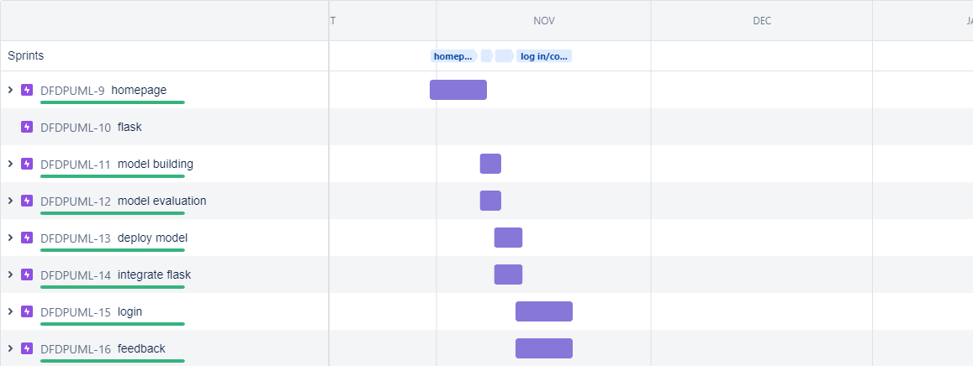

BURNDOWN GRAPH

